3143 Building Inspection Lab Report

Xinyu Liu

# General Description

The building in this inspection labs is the No. 4 building on Xipu campus of Southwest Jiaotong University. No. 4 Building is used by the schools of geosciences and environmental engineering and the department of civil engineering. No. 4 building is quite a huge complex and, in this lab, I will only focus on the part belong to our faculty.

## Fire Department access

建筑的门口

***Figure 1. Fire Department Access for No. 4 Building.***

The fire department access is denoted by the red box. And it is about 12 meters width.

## Usage of the building

There is a total of 5 floors in No. 4 Building.

1. The first floor is used as classrooms and the guard houses. And there are elevators lobby and the washrooms.
2. The second floor is used as classrooms, meeting rooms as well as office rooms. And there are elevators lobby and the washrooms.
3. There is no classroom in third floor. And there are only offices rooms and meeting rooms. And there are elevators lobby and the washrooms.
4. Floor four is consisted with classrooms and storage room, including some papers, files and some equipment. And there are elevators lobby and the washrooms.
5. Floors five is consisted with office rooms and meeting rooms. And there are elevators lobby and the washrooms.

## Types of People

The majority of the people there are students, professors, as well as some administrative officers in the building. However, there will be some inspectors, guards, cleaners and maintenance people there from time to time.

## Approximate numbers of people

The arrangement of room and people in different floor are assumed to be the same.

On floor 1, there is 13 office rooms and 8 classrooms. Each classroom has 30 seats and no table, and every offices has two table that can hold for a total of 4 people. The occupant load for the elevator lobby and the washroom will not be accounted for the regular daily occupancy load. So the number of people in the first floor is 292.

So the total occupant load for the No. 4 building is 1168 people.

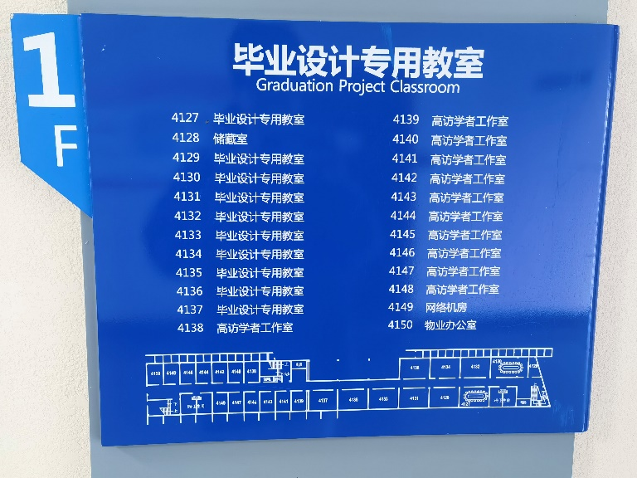

***Figure 2 Arrangements of rooms in floor 1***

## Description of the fire load

***Figure 3 Fire Road***

By approximation, the length of the fire road is about 1200 meters.

## Description of Fire Load

For the convenience of calculation, the fire load for each floor is assumed to be the same.

Approximately speaking, the wood, paper and rubber in building No. 4 should be calculated through the following formula.



So by my observation, the material listed in each floor of the No. 4 building is similar to

|  |  |  |  |
| --- | --- | --- | --- |
| Material | Quantity(Kg) | Area(m2) | Calorific Value (Kj/Kg) |
| Paper | 2500 | 1500 | 156,000 |
| Wood | 5000 | 1500 | 175,000 |
| Rubber | 1000 | 1500 | 400,000 |



So, the total fire Load for the building should be 5550

# Structural Fire Protection

In this part, I am going to record and discuss some structural fire protection for the building No. 4, including but not limited to hydrants, detectors, fire suppression equipment, and etc.

## Fire Protection System

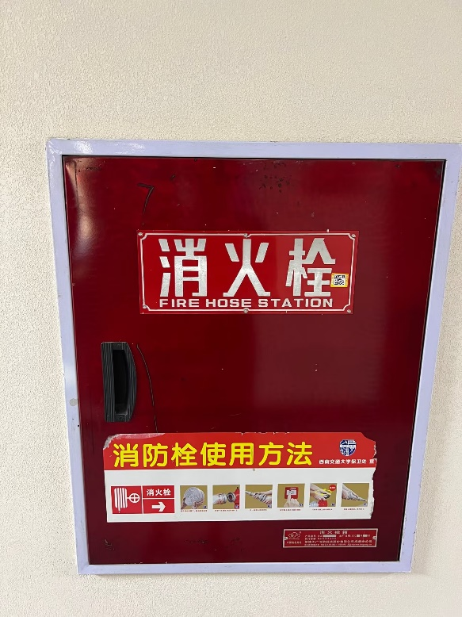在门上

***Figure 4 Fire Hose Station***

***Figure 5 Smoke Detectors***

房间的摆设布局

***Figure 6 Strobes***

墙上的海报

***Figure 7 Emergency Exit Sign and Pull Station***

It can be seem from the figure 4-7 that the there are several fire protection components in No. 4 Building, including the fire hose station, pull station, emergency exist, notification equipment, detectors.

However, no sprinklers are spotted in the building No. 4. Which could be a serious safety issue here.

## Smoke Exhaust System

No Smoke Exhaust System is spotted.

## Location of Nearest Hydrants

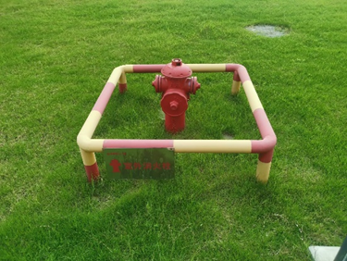

***Figure 8 Location of the nearest hydrants.***

The nearest fire hydrant is located on the Northwest of the No. 4 building which is about 30 meters from the fire department access.

## PIVs

No PIVs was founded outside the No. 4 building.

## Fire Department Connections

The access to the riser room is limited and I cannot get into it. So I can not get the picture of the fire department connection. Actually, I do not even know the relative location of the riser room, so I could not take a picture of it outside the building.

## Construction Classification

Type III construction. The exterior wall are of noncombustible matorrals and the interior building materials are of any materials allowed by code.

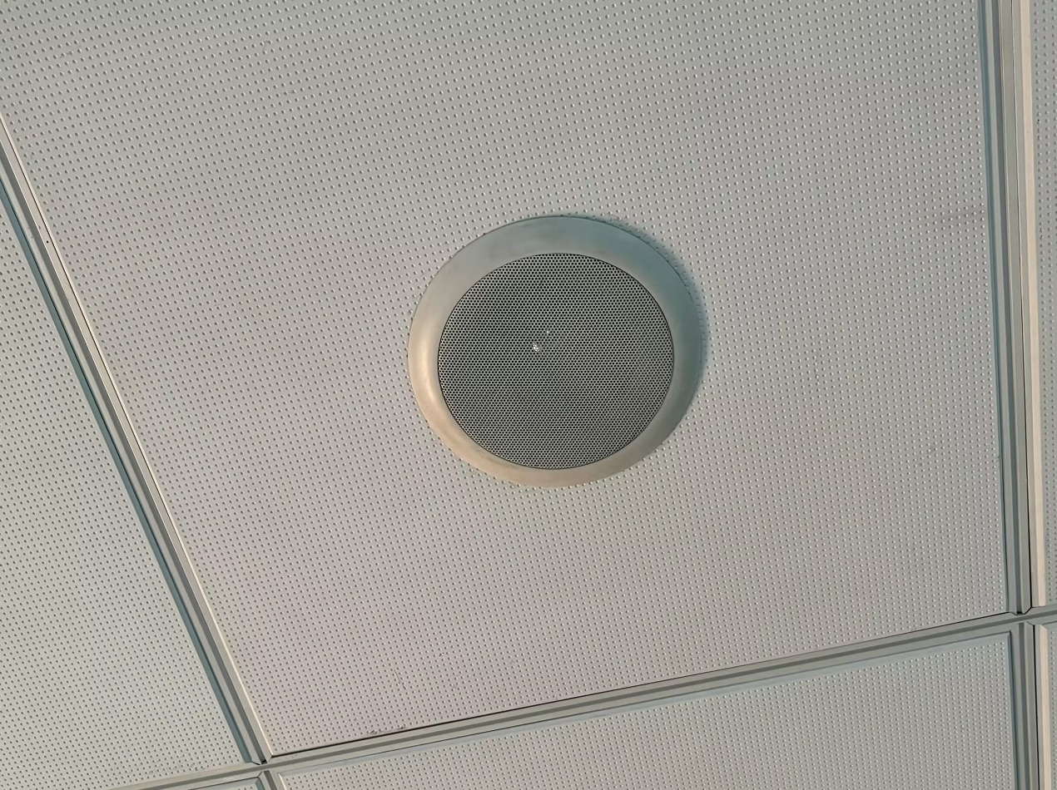

Figure 9 Use of any materials listed by the code

## Fire Barriers

***Figure 10 Lifting fire door to prevent the spread of vegetation ignition***

## Interior Finishes

Interior Finishes are all simple painted wall, with some posters made of combustible materials. There is seldom stacked materials on the corridors.

# Description of Means of Egress

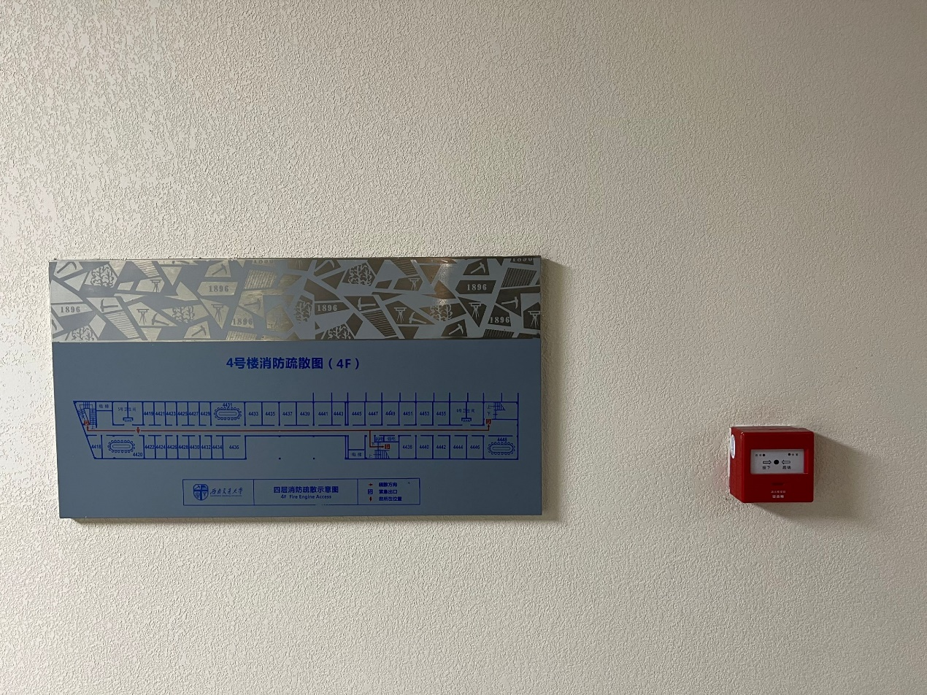

***Figure 11 Fire Emergency Egress Plan***

The emergency fire escape road is listed on this figure.

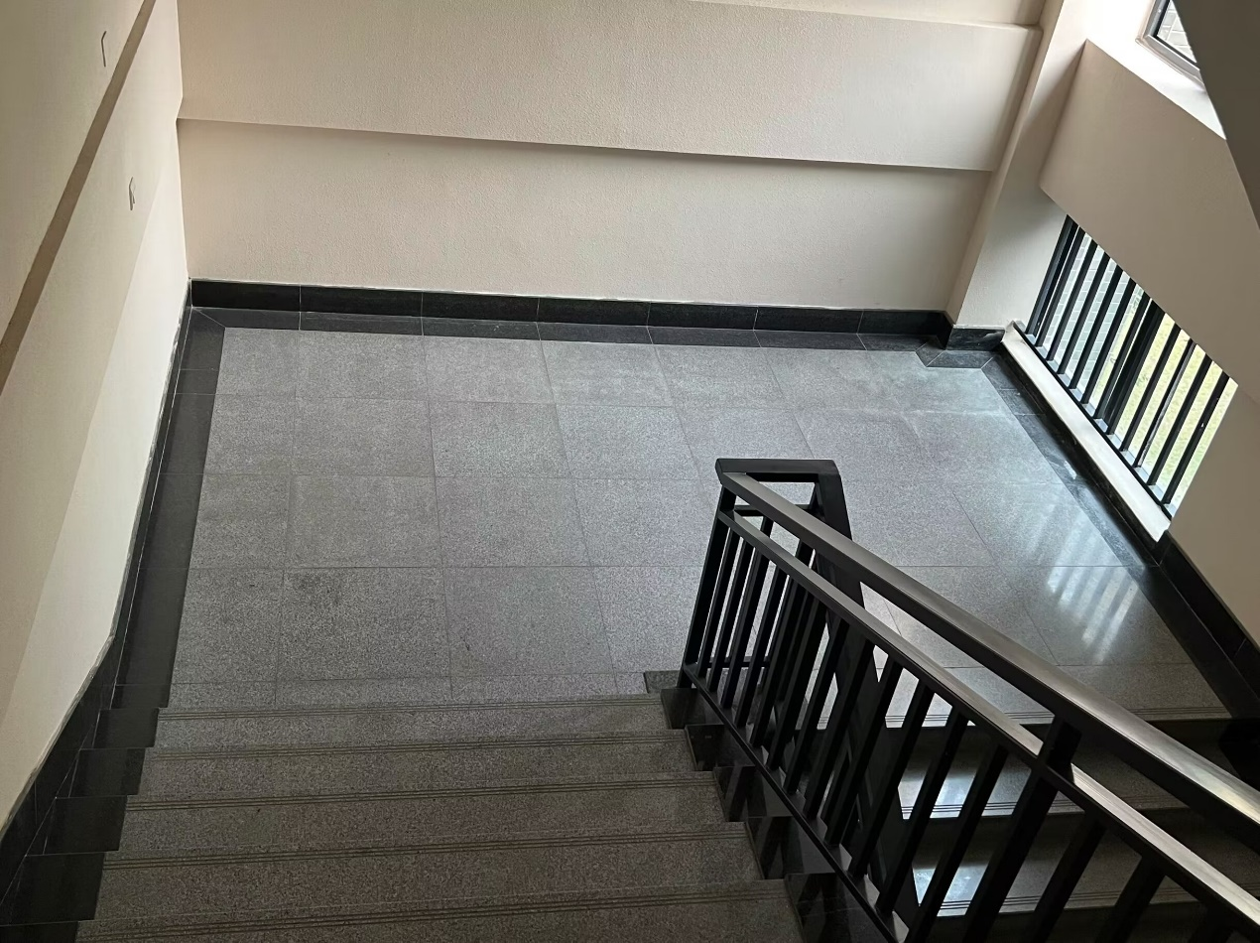

***Figure 12 Landings of the stairways***

***Figure 13 Slope, width and depth of each step***

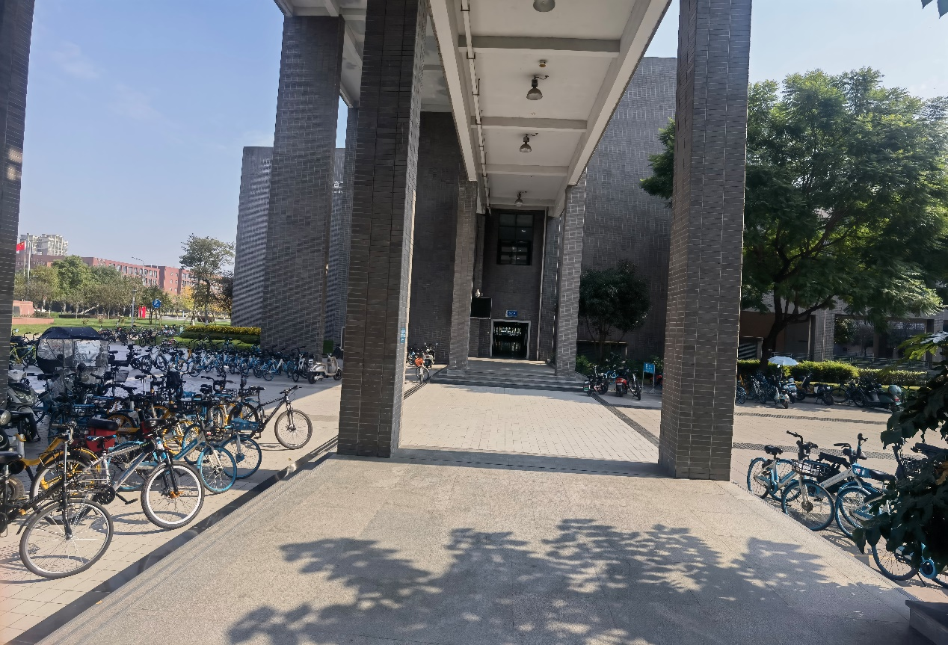

***Figure 14 Egress of the building***

In this section, the dimension of the stairways have been measured and recorded. The dimension of the landing is 5m by 3m. The depth and tread of the stairway is 15 cm by 35 cm. And the width is 3 m.

The width of the Egress is 4.5 m, and the common travel distance in No. 4 building is 70m.

# Analysis

* Neither IBC or NPFA applied in China, so we do not have a classification of No. 4 building, such a building with multiple usage. And the code enforcement, inspection in China is not as strictly as that of in China. For example, it can be observed in Figure 14 that there are so may bikes as the barriers to the emergency escape.
* Per the building, I did not see any riser room. I wonder whether these risers exist or not.
* There must be some missing components compared with the teaching building in the US. For example the PIV, the fire doors, and the emergency lighting.

# Recommendations for improvement

1. All the bikes in the emergency escape road should be removed, or at least a common path should be cleared.
2. The barriers on the fire department access should be removed. For now, I have spotted two type of barriers. The first one is the tree plant on the road, and the second the large road restrictions. It is really a serious problem, as I walked all around the building No. 4, without seeing any potential places that fire fighting truck is able to access.
3. Regular fire drills should be done to ensure that everyone is prepared for emergencies. To avoid significant rust, check the fire riser's condition frequently. Check the safety exit signs often for deterioration. During the day, the exit should be left unlocked. Nothing should hinder the exit discharge.
4. The NO.4 teaching building only has one fire-rated door at horizontal exits, which makes it impossible to create a closed space. It is recommended to install two doors in the middle of the hallway to ensure everyone's safety.